
UGANDA INDUSTRIAL RESEARCH INSTITUTE
Namanve Industrial and Business Park, Mukono District, Uganda
DATABASE DESIGN DOCUMENT
DESIGN AND DEVELOPMENT OF A WEB BASED
INVENTORY MANAGEMENT SYSTEM
FOR UGANDA INDUSTRIAL RESEARCH INSTITUTE (UIRI)
NAKAWA AND NAMANVE CAMPUSES
Name | Registration Number | Project Responsibility
Keith Paul Kato | 24/U/26593/EVE | Lead reporting, database design and documentation coordination
Komukama Tracy | 24/U/06151/EXT | Requirements review, user needs analysis and supporting documentation
Atuhiire Deo Kamate | 24/U/14365/PS | System analysis, testing support and validation of database design decisions

Project Detail | Description
Programme | Bachelor of Science in Computer Science
Institution | Makerere University, Kampala
Host Organisation | Uganda Industrial Research Institute (UIRI)
Department | Information and Communications Technology (ICT)
Field Supervisor | Mr. William Kakooza: IT Engineer at UIRI
Submitted to | ICT Team, UIRI Namanve
Document Type | Database Design, Data Dictionary and ERD Documentation
Submission Date | July-August 2026

Document Control
This document defines the database design for the proposed UIRI Inventory Management System. It converts the approved proposal and SRS into a relational data model, data dictionary, relationship rules and normalization evidence for implementation in MySQL or MariaDB.
Table 1 Document Control Details
Item | Description
Document Title | Database Design Document for the UIRI Inventory Management System
Version | 1.0
Prepared For | ICT Team, Uganda Industrial Research Institute, Namanve
Prepared By | Keith Paul Kato, Komukama Tracy and Atuhiire Deo Kamate
Primary Design Responsibility | Keith Paul Kato
Design Method | Requirements to conceptual design, logical design and physical relational design
Target DBMS | MySQL or MariaDB
Normalization Target | At least Third Normal Form with additional integrity constraints where necessary

Revision History
Table 2 Revision History
Version | Date | Description | Prepared By
1.0 | July-August 2026 | Initial database design document prepared after SRS approval | Project Team

Table of Contents
Document Control 2
Revision History 2
List of Tables 4
List of Figures 6
Abbreviations and Acronyms 7
1.0 Introduction 8
2.0 Database Design Objectives 8
3.0 Design Assumptions and Naming Standards 9
4.0 Business Rules 9
5.0 Entity Identification 10
6.0 Conceptual Database Design 11
7.0 Logical Database Design 13
8.0 Enhanced Entity Relationship Design 17
9.0 Data Dictionary 19
10.0 Relationship Summary 27
11.0 Normalization Evidence 28
12.0 Database Constraints and Integrity Rules 29
13.0 Report Support Mapping 30
14.0 Security, Audit and Access Control Design 30
15.0 Implementation Notes for MySQL 31
16.0 Conclusion 32
17.0 References 32

List of Tables
Table 1 Document Control Details
Table 2 Revision History
Table 3 Acronyms and Abbreviations
Table 4 Database Design Objectives
Table 5 Database Naming Standards
Table 6 Business Rules
Table 7 Entity Identification Summary
Table 8 Data Dictionary for roles
Table 9 Data Dictionary for users
Table 10 Data Dictionary for campuses
Table 11 Data Dictionary for departments
Table 12 Data Dictionary for locations
Table 13 Data Dictionary for inventory_categories
Table 14 Data Dictionary for units_of_measure
Table 15 Data Dictionary for item_types
Table 16 Data Dictionary for inventory_items
Table 17 Data Dictionary for suppliers
Table 18 Data Dictionary for supplier_items
Table 19 Data Dictionary for acquisition_batches
Table 20 Data Dictionary for asset_statuses
Table 21 Data Dictionary for asset_instances
Table 22 Data Dictionary for stock_balances
Table 23 Data Dictionary for transaction_types
Table 24 Data Dictionary for stock_transactions
Table 25 Data Dictionary for requisitions
Table 26 Data Dictionary for requisition_lines
Table 27 Data Dictionary for maintenance_records
Table 28 Data Dictionary for audit_logs
Table 29 Data Dictionary for report_logs
Table 30 Relationship Summary
Table 31 Normalization Summary
Table 32 Database Integrity Rules
Table 33 Report Support Mapping
Table 34 Security and Audit Mapping
Table 35 Recommended Indexes

List of Figures
Figure 1 Conceptual ERD for the UIRI Inventory Management System
Figure 2 Logical ERD for Master Data and Inventory Catalogue
Figure 3 Logical ERD for Stock Movement and Asset Tracking
Figure 4 Logical ERD for Requisitions, Maintenance and Audit Records
Figure 5 Enhanced ERD Showing Item Specialization

Abbreviations and Acronyms
Table 3 Acronyms and Abbreviations
Acronym | Full Form
DBMS | Database Management System
ERD | Entity Relationship Diagram
EERD | Enhanced Entity Relationship Diagram
FK | Foreign Key
ICT | Information and Communications Technology
IMS | Inventory Management System
MMISDC | Machining, Manufacturing and Industrial Skills Development Centre
PK | Primary Key
RBAC | Role Based Access Control
SRS | Software Requirements Specification
UIRI | Uganda Industrial Research Institute
UOM | Unit of Measure

1.0 Introduction
This Database Design Document presents the data model for the web based Inventory Management System proposed for Uganda Industrial Research Institute. It is prepared after the System Proposal and Software Requirements Specification and is intended to guide the implementation of the database layer, ER diagrams, data dictionary, validation rules and later source code development.
The design responds to the inventory tracking needs identified by the UIRI ICT Team project brief, including item registration, stock movement, supplier records, reports, low stock alerts, user authorization and audit logging [1]. The design also supports the institutional need to report on computers, brands, specifications, year of purchase, acquisition batches, faulty assets, operational assets, serial numbers and location records.
The database has been designed as a normalized relational model. It separates users, campuses, departments, locations, categories, suppliers, item catalogue records, asset instances, stock balances, stock transactions, requisitions, maintenance records, audit logs and report logs. This separation reduces duplication and supports accurate reports.

1.1 Purpose of the Document
The purpose of this document is to define the database structure before coding begins. It provides business rules, entity identification, conceptual ERD, logical ERD, enhanced ERD, data dictionary, normalization evidence and implementation constraints.

1.2 Scope of the Database Design
The scope covers the inventory database for Nakawa and Namanve campuses. The initial pilot may be implemented at UIRI Namanve, but the database includes campus and department tables so that Nakawa can be supported without redesigning the database.

2.0 Database Design Objectives
Table 4 Database Design Objectives
Objective ID | Database Design Objective
DO-01 | Support accurate registration of inventory items, categories, suppliers and users.
DO-02 | Track both consumable stock and durable fixed assets without mixing their data incorrectly.
DO-03 | Allow individual assets such as computers, laboratory equipment and machines to be tracked by serial number, asset tag, purchase year, batch, condition, department and location.
DO-04 | Maintain stock balances for consumables and other quantity based items by location.
DO-05 | Record every stock movement such as receipt, issue, transfer, return, adjustment and disposal.
DO-06 | Support supplier transaction history and acquisition batch reporting.
DO-07 | Preserve audit evidence of important user actions for accountability.
DO-08 | Provide a reliable database foundation for dashboard summaries and management reports.
DO-09 | Reduce redundancy and update anomalies through normalization to at least 3NF.
DO-10 | Keep the design implementable using MySQL or MariaDB in the internship prototype environment.

3.0 Design Assumptions and Naming Standards
The following assumptions guide the design. Real inventory records may be incomplete during the first data collection exercise, so the system must support cleaned historical entries and dummy data for demonstration where institutional data is sensitive. Every item belongs to an item category. Every stock movement is performed by a valid system user. Every physical location belongs to a campus and may also be linked to a department. Every fixed asset should have either an asset tag, a serial number or both, depending on the nature of the item.
Table 5 Database Naming Standards
Standard Area | Adopted Standard
Table names | Lowercase plural names, for example users, campuses and inventory_items
Primary keys | Single integer surrogate key ending with _id, for example item_id
Foreign keys | Use the referenced table name in singular form where practical, for example department_id
Dates and times | Use DATE where time is not needed and DATETIME where audit time matters
Quantities | Use DECIMAL for stock quantities to allow units such as litres, metres or kilograms
Text fields | Use VARCHAR for short text and TEXT for long descriptions
Status values | Use lookup tables for important statuses, or controlled values where lookup tables are not necessary
Deletion rules | Do not physically delete records that have transactions. Deactivate or archive them instead

4.0 Business Rules
Table 6 Business Rules
Rule ID | Business Rule
BR-01 | One campus can have many departments, but each department belongs to one campus.
BR-02 | One campus can have many inventory locations. Each location belongs to one campus and may belong to one department.
BR-03 | One user belongs to one role. One role may be assigned to many users.
BR-04 | One user may be linked to one department for accountability and report filtering.
BR-05 | One category can classify many inventory items. Each inventory item belongs to one category.
BR-06 | One inventory item has one unit of measure and one item type.
BR-07 | A supplier can supply many items and an item can be supplied by many suppliers. This is resolved using the supplier_items table.
BR-08 | A fixed asset item can have many asset instances. Each asset instance represents one physical asset.
BR-09 | An asset instance may belong to one acquisition batch, but one acquisition batch can create many asset instances.
BR-10 | A consumable or quantity based item can have stock balances in several locations.
BR-11 | Each stock transaction must have one transaction type, one item, a quantity, a transaction date and the user who recorded it.
BR-12 | A stock transaction may reference a supplier for received stock and may reference a specific asset instance for fixed asset movement.
BR-13 | Stock issue cannot reduce a stock balance below zero unless the transaction is an approved correction handled by an authorized user.
BR-14 | Each asset instance has one current status such as operational, faulty, under maintenance, retired, disposed or lost.
BR-15 | One asset instance can have many maintenance records. Each maintenance record belongs to one asset instance.
BR-16 | A requisition can contain many requested items through requisition_lines.
BR-17 | Audit logs are append only records and must not be edited by ordinary users.
BR-18 | Reports are generated from database records and may be logged in report_logs for accountability.

5.0 Entity Identification
Table 7 Entity Identification Summary
Entity | Purpose
Role | Defines the access level of a user, such as Administrator, Store Manager, Staff User, Management Viewer or Auditor.
UserAccount | Stores system users, login identifiers, department links and role assignments.
Campus | Stores UIRI campus records such as Nakawa and Namanve.
Department | Stores departments or sections under a campus.
Location | Stores physical inventory locations such as stores, laboratories, workshops, rooms and offices.
InventoryCategory | Groups items into categories such as ICT Equipment, Laboratory Equipment and Consumables.
UnitOfMeasure | Defines units such as pieces, boxes, litres, kilograms and metres.
ItemType | Classifies whether an item is a consumable, fixed asset or both.
InventoryItem | Stores the catalogue record for each item type.
Supplier | Stores supplier identification and contact information.
SupplierItem | Resolves the many to many relationship between suppliers and inventory items.
AcquisitionBatch | Stores batch, purchase reference and receipt information for assets or stock received together.
AssetStatus | Stores controlled asset condition values.
AssetInstance | Stores individual durable assets with serial numbers, asset tags and current status.
StockBalance | Stores current item quantity by location.
TransactionType | Stores transaction categories such as stock in, stock out, transfer, return, adjustment and disposal.
StockTransaction | Stores historical stock movement records.
Requisition | Stores inventory requests made by staff or departments.
RequisitionLine | Stores each item requested under a requisition.
MaintenanceRecord | Stores fault, repair and maintenance history for assets.
AuditLog | Stores important user actions for accountability.
ReportLog | Stores report generation events where report access needs to be audited.

6.0 Conceptual Database Design
The conceptual model focuses on the main business objects and their relationships without exposing every physical attribute. It helps stakeholders understand the database before the design is converted into tables and foreign keys.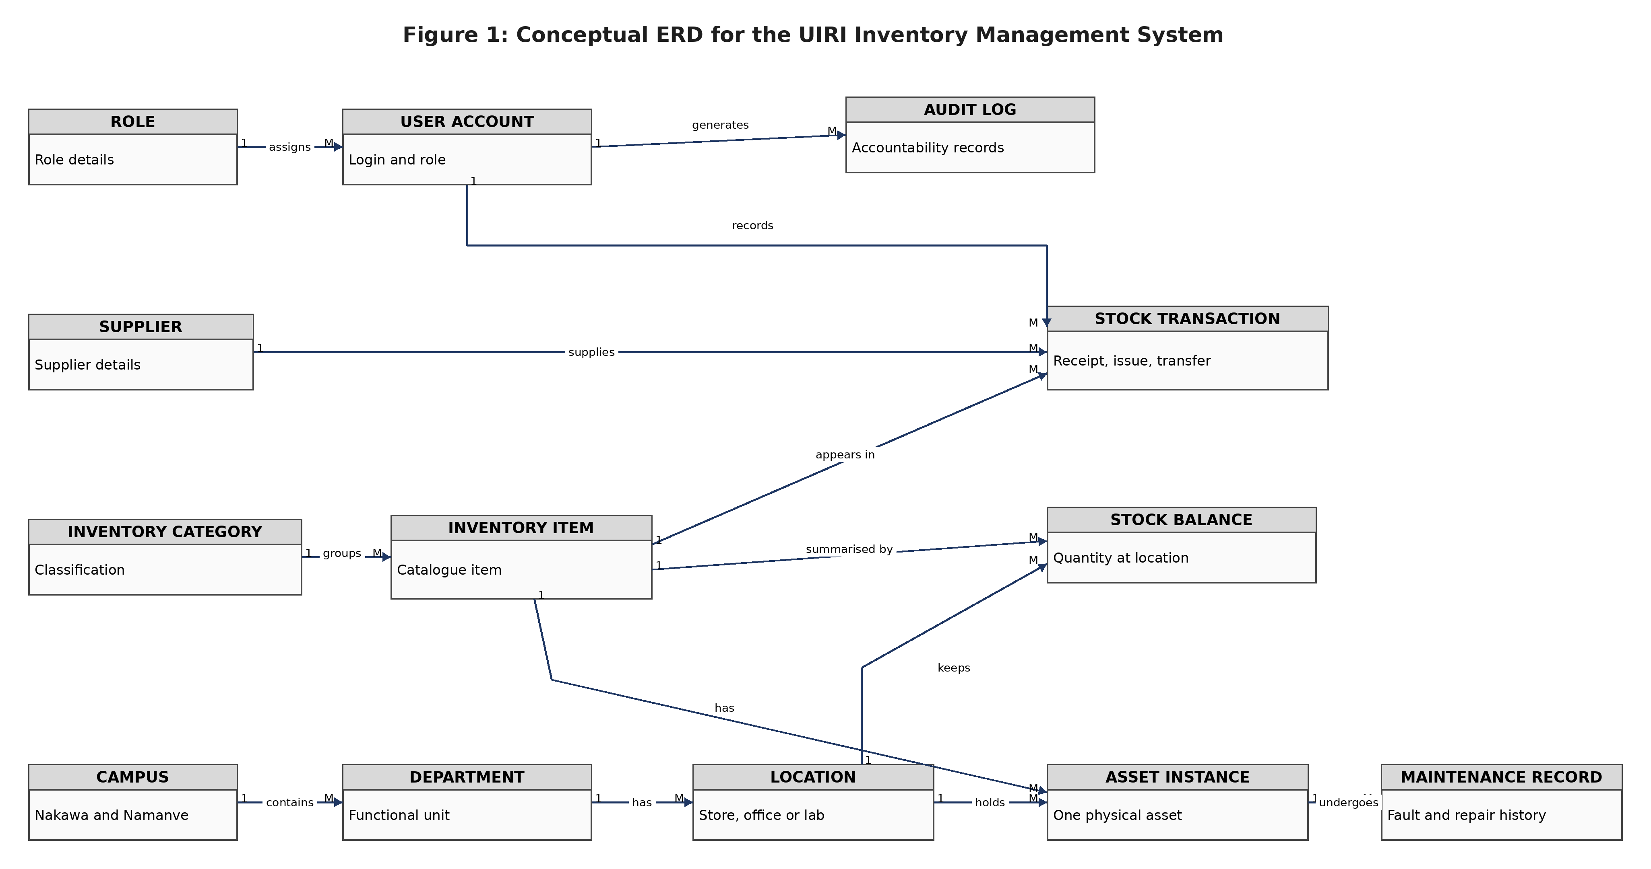
Figure 1 Conceptual ERD for the UIRI Inventory Management System

7.0 Logical Database Design
The logical database design converts the conceptual entities into relational tables. The design uses primary keys, foreign keys and relationship constraints to preserve data integrity. For readability, the logical ERD is presented in three Visio-style views: master data, stock movement and asset tracking, and requisitions with audit records.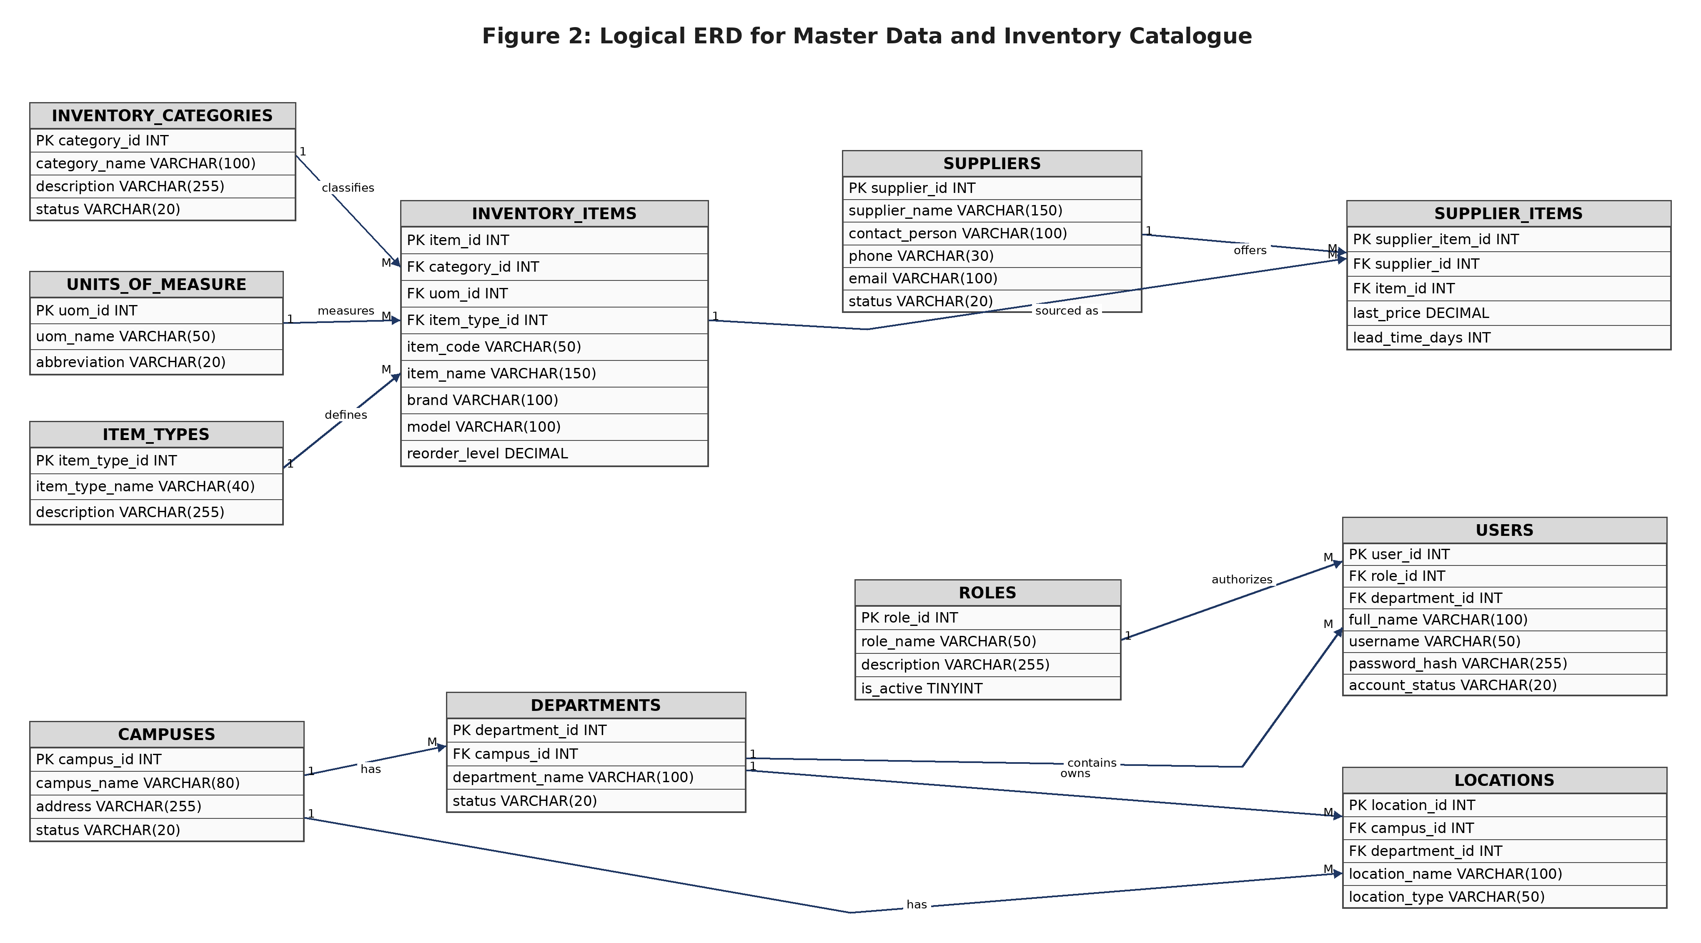
Figure 2 Logical ERD for Master Data and Inventory Catalogue

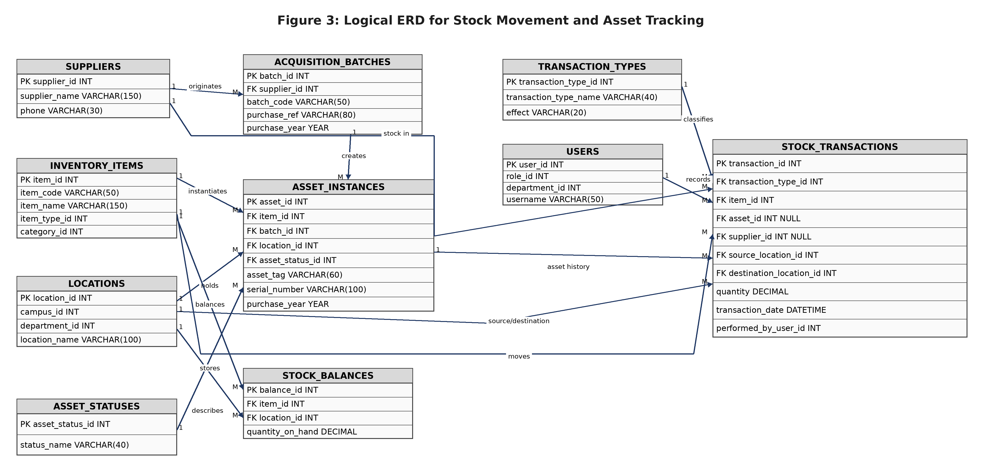
Figure 3 Logical ERD for Stock Movement and Asset Tracking

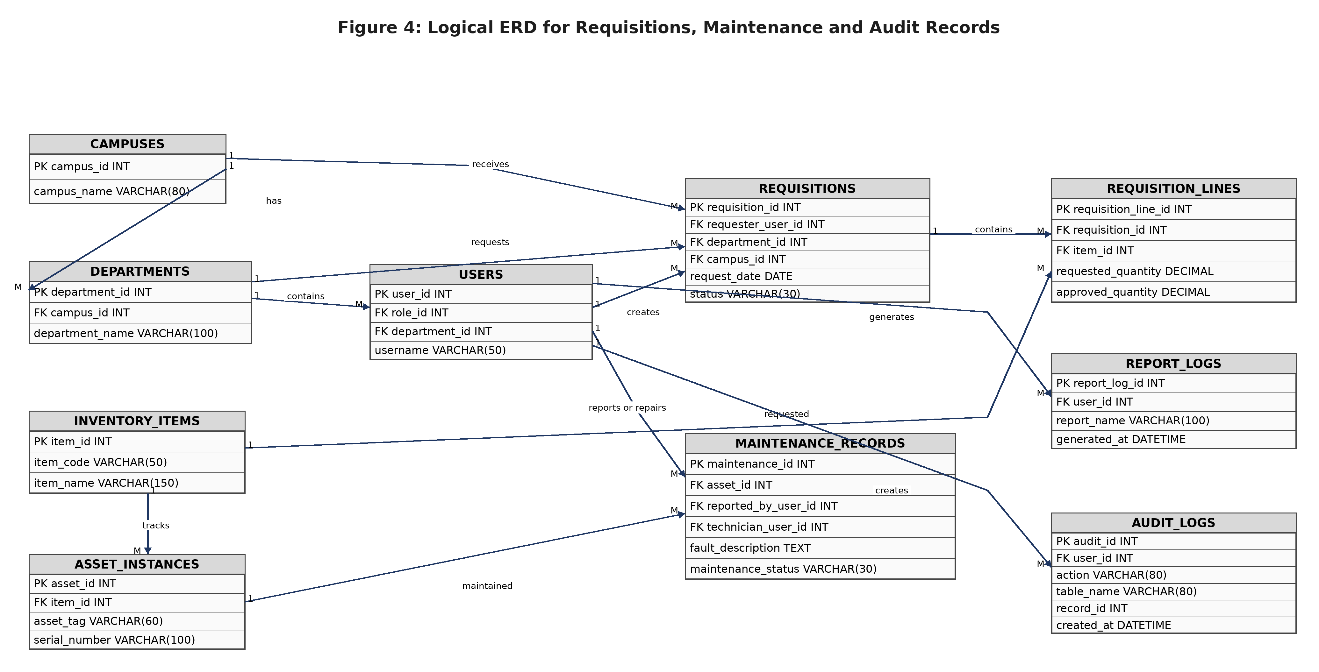
Figure 4 Logical ERD for Requisitions, Maintenance and Audit Records

8.0 Enhanced Entity Relationship Design
The enhanced ERD clarifies a critical design decision for UIRI. The system must not treat all items as simple quantities. Consumables are quantity tracked, while fixed assets are individually tracked through asset_instances. This distinction is necessary for reports such as computers in Mechatronics, assets by serial number, faulty equipment and acquisition batches.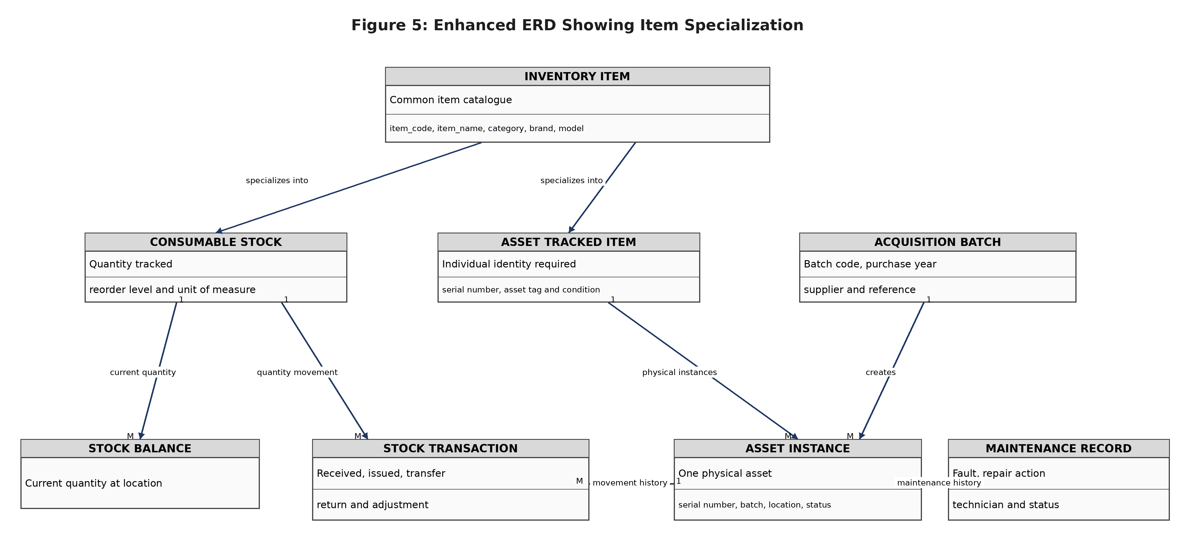
Figure 5 Enhanced ERD Showing Item Specialization

9.0 Data Dictionary
The data dictionary defines each proposed table, field, data type, key constraint and field purpose. Data types are specified for MySQL or MariaDB implementation and may be slightly adjusted during physical implementation where justified by testing.

9.1 roles
Table 8 Data Dictionary for roles
Field | Data Type | Key or Constraint | Description
role_id | INT | PK, AI, NN | Unique role identifier
role_name | VARCHAR(50) | UNIQUE, NN | Role name such as Administrator or Store Manager
description | VARCHAR(255) | NULL | Role description
is_active | TINYINT | NN, default 1 | Indicates whether the role is active
created_at | DATETIME | NN | Date and time the role was created

9.2 users
Table 9 Data Dictionary for users
Field | Data Type | Key or Constraint | Description
user_id | INT | PK, AI, NN | Unique user identifier
role_id | INT | FK roles.role_id, NN | Role assigned to the user
department_id | INT | FK departments.department_id, NULL | User department where applicable
full_name | VARCHAR(100) | NN | Full name of the user
username | VARCHAR(50) | UNIQUE, NN | Login username
email | VARCHAR(100) | UNIQUE, NULL | User email address
phone | VARCHAR(30) | NULL | User phone contact
password_hash | VARCHAR(255) | NN | Hashed password value
account_status | VARCHAR(20) | NN | Active, inactive or locked
created_at | DATETIME | NN | Account creation timestamp
updated_at | DATETIME | NULL | Last account update timestamp

9.3 campuses
Table 10 Data Dictionary for campuses
Field | Data Type | Key or Constraint | Description
campus_id | INT | PK, AI, NN | Unique campus identifier
campus_name | VARCHAR(80) | UNIQUE, NN | Campus name such as Namanve or Nakawa
address | VARCHAR(255) | NULL | Campus address
status | VARCHAR(20) | NN | Active or inactive

9.4 departments
Table 11 Data Dictionary for departments
Field | Data Type | Key or Constraint | Description
department_id | INT | PK, AI, NN | Unique department identifier
campus_id | INT | FK campuses.campus_id, NN | Campus to which the department belongs
department_name | VARCHAR(100) | NN | Department or section name
description | VARCHAR(255) | NULL | Department description
status | VARCHAR(20) | NN | Active or inactive

9.5 locations
Table 12 Data Dictionary for locations
Field | Data Type | Key or Constraint | Description
location_id | INT | PK, AI, NN | Unique physical location identifier
campus_id | INT | FK campuses.campus_id, NN | Campus where the location is found
department_id | INT | FK departments.department_id, NULL | Department associated with the location
location_name | VARCHAR(100) | NN | Room, office, store or workshop name
location_type | VARCHAR(50) | NULL | Store, laboratory, workshop, office or room
description | VARCHAR(255) | NULL | Additional location notes
status | VARCHAR(20) | NN | Active or inactive

9.6 inventory_categories
Table 13 Data Dictionary for inventory_categories
Field | Data Type | Key or Constraint | Description
category_id | INT | PK, AI, NN | Unique category identifier
category_name | VARCHAR(100) | UNIQUE, NN | Inventory category name
description | VARCHAR(255) | NULL | Category description
status | VARCHAR(20) | NN | Active or inactive

9.7 units_of_measure
Table 14 Data Dictionary for units_of_measure
Field | Data Type | Key or Constraint | Description
uom_id | INT | PK, AI, NN | Unique unit identifier
uom_name | VARCHAR(50) | UNIQUE, NN | Full unit name
abbreviation | VARCHAR(20) | UNIQUE, NN | Short unit label such as pcs or kg

9.8 item_types
Table 15 Data Dictionary for item_types
Field | Data Type | Key or Constraint | Description
item_type_id | INT | PK, AI, NN | Unique item type identifier
item_type_name | VARCHAR(40) | UNIQUE, NN | Consumable, Fixed Asset or Both
description | VARCHAR(255) | NULL | Explains how items of this type are tracked

9.9 inventory_items
Table 16 Data Dictionary for inventory_items
Field | Data Type | Key or Constraint | Description
item_id | INT | PK, AI, NN | Unique item catalogue identifier
category_id | INT | FK inventory_categories.category_id, NN | Item category
uom_id | INT | FK units_of_measure.uom_id, NN | Unit of measure
item_type_id | INT | FK item_types.item_type_id, NN | Tracking type
item_code | VARCHAR(50) | UNIQUE, NN | Internal item code
item_name | VARCHAR(150) | NN | Item name
brand | VARCHAR(100) | NULL | Brand name where applicable
model | VARCHAR(100) | NULL | Model where applicable
specification | TEXT | NULL | Technical specification
description | TEXT | NULL | General item description
reorder_level | DECIMAL(12,2) | NN, default 0 | Minimum stock level
image_path | VARCHAR(255) | NULL | Stored item image path
is_active | TINYINT | NN, default 1 | Indicates whether item is active
created_at | DATETIME | NN | Creation timestamp

9.10 suppliers
Table 17 Data Dictionary for suppliers
Field | Data Type | Key or Constraint | Description
supplier_id | INT | PK, AI, NN | Unique supplier identifier
supplier_name | VARCHAR(150) | NN | Supplier business name
contact_person | VARCHAR(100) | NULL | Main contact person
phone | VARCHAR(30) | NULL | Supplier phone contact
email | VARCHAR(100) | NULL | Supplier email
address | VARCHAR(255) | NULL | Supplier address
status | VARCHAR(20) | NN | Active or inactive

9.11 supplier_items
Table 18 Data Dictionary for supplier_items
Field | Data Type | Key or Constraint | Description
supplier_item_id | INT | PK, AI, NN | Unique supplier item identifier
supplier_id | INT | FK suppliers.supplier_id, NN | Supplier
item_id | INT | FK inventory_items.item_id, NN | Item supplied
preferred_status | VARCHAR(20) | NULL | Preferred or alternate supplier indicator
last_price | DECIMAL(12,2) | NULL | Last known price
lead_time_days | INT | NULL | Expected supply lead time
unique_supplier_item | CONSTRAINT | UNIQUE supplier_id, item_id | Prevents duplicate supplier item links

9.12 acquisition_batches
Table 19 Data Dictionary for acquisition_batches
Field | Data Type | Key or Constraint | Description
batch_id | INT | PK, AI, NN | Unique batch identifier
supplier_id | INT | FK suppliers.supplier_id, NULL | Supplier linked to the batch
batch_code | VARCHAR(50) | UNIQUE, NN | Batch or acquisition code
purchase_ref | VARCHAR(80) | NULL | Purchase order or receipt reference
received_date | DATE | NULL | Date the batch was received
purchase_year | YEAR | NULL | Year of purchase
notes | TEXT | NULL | Additional batch notes

9.13 asset_statuses
Table 20 Data Dictionary for asset_statuses
Field | Data Type | Key or Constraint | Description
asset_status_id | INT | PK, AI, NN | Unique status identifier
status_name | VARCHAR(40) | UNIQUE, NN | Operational, faulty, under maintenance, retired, disposed or lost
description | VARCHAR(255) | NULL | Status explanation

9.14 asset_instances
Table 21 Data Dictionary for asset_instances
Field | Data Type | Key or Constraint | Description
asset_id | INT | PK, AI, NN | Unique physical asset identifier
item_id | INT | FK inventory_items.item_id, NN | Catalogue item represented by the asset
batch_id | INT | FK acquisition_batches.batch_id, NULL | Acquisition batch
location_id | INT | FK locations.location_id, NN | Current physical location
department_id | INT | FK departments.department_id, NULL | Current responsible department
custodian_user_id | INT | FK users.user_id, NULL | Current custodian where applicable
asset_tag | VARCHAR(60) | UNIQUE, NN | Internal asset tag
serial_number | VARCHAR(100) | UNIQUE, NULL | Manufacturer serial number
purchase_year | YEAR | NULL | Purchase year
purchase_date | DATE | NULL | Purchase date
acquisition_cost | DECIMAL(12,2) | NULL | Recorded cost if available
asset_status_id | INT | FK asset_statuses.asset_status_id, NN | Current condition or status
warranty_expiry_date | DATE | NULL | Warranty expiry where applicable
remarks | TEXT | NULL | Additional asset notes

9.15 stock_balances
Table 22 Data Dictionary for stock_balances
Field | Data Type | Key or Constraint | Description
balance_id | INT | PK, AI, NN | Unique balance row identifier
item_id | INT | FK inventory_items.item_id, NN | Item whose quantity is held
location_id | INT | FK locations.location_id, NN | Location where quantity is held
quantity_on_hand | DECIMAL(12,2) | NN, default 0 | Current available quantity
reorder_level_override | DECIMAL(12,2) | NULL | Location-specific reorder threshold
last_updated_at | DATETIME | NN | Last balance update timestamp
unique_item_location | CONSTRAINT | UNIQUE item_id, location_id | Prevents duplicate balance rows

9.16 transaction_types
Table 23 Data Dictionary for transaction_types
Field | Data Type | Key or Constraint | Description
transaction_type_id | INT | PK, AI, NN | Unique transaction type identifier
transaction_type_name | VARCHAR(40) | UNIQUE, NN | Stock In, Stock Out, Transfer, Return, Adjustment or Disposal
effect | VARCHAR(20) | NN | Increase, decrease, move or no balance
description | VARCHAR(255) | NULL | Explanation of transaction effect

9.17 stock_transactions
Table 24 Data Dictionary for stock_transactions
Field | Data Type | Key or Constraint | Description
transaction_id | INT | PK, AI, NN | Unique stock transaction identifier
transaction_type_id | INT | FK transaction_types.transaction_type_id, NN | Type of stock movement
item_id | INT | FK inventory_items.item_id, NN | Item being moved
asset_id | INT | FK asset_instances.asset_id, NULL | Specific asset moved where applicable
supplier_id | INT | FK suppliers.supplier_id, NULL | Supplier for received stock
source_location_id | INT | FK locations.location_id, NULL | Source location
destination_location_id | INT | FK locations.location_id, NULL | Destination location
quantity | DECIMAL(12,2) | NN | Quantity moved
reference_no | VARCHAR(80) | NULL | Voucher, receipt or request reference
transaction_date | DATETIME | NN | Transaction date and time
performed_by_user_id | INT | FK users.user_id, NN | User who recorded the transaction
approved_by_user_id | INT | FK users.user_id, NULL | User who approved the transaction
remarks | TEXT | NULL | Transaction notes

9.18 requisitions
Table 25 Data Dictionary for requisitions
Field | Data Type | Key or Constraint | Description
requisition_id | INT | PK, AI, NN | Unique requisition identifier
requester_user_id | INT | FK users.user_id, NN | User who made the request
department_id | INT | FK departments.department_id, NN | Requesting department
campus_id | INT | FK campuses.campus_id, NN | Requesting campus
request_date | DATE | NN | Date of request
required_date | DATE | NULL | Date item is needed
status | VARCHAR(30) | NN | Pending, approved, rejected, issued or cancelled
purpose | TEXT | NULL | Reason for the request
approved_by_user_id | INT | FK users.user_id, NULL | Approving user

9.19 requisition_lines
Table 26 Data Dictionary for requisition_lines
Field | Data Type | Key or Constraint | Description
requisition_line_id | INT | PK, AI, NN | Unique requisition line identifier
requisition_id | INT | FK requisitions.requisition_id, NN | Parent requisition
item_id | INT | FK inventory_items.item_id, NN | Requested item
requested_quantity | DECIMAL(12,2) | NN | Quantity requested
approved_quantity | DECIMAL(12,2) | NULL | Quantity approved
issued_quantity | DECIMAL(12,2) | NULL | Quantity issued
line_status | VARCHAR(30) | NN | Pending, approved, issued or rejected
remarks | TEXT | NULL | Line notes

9.20 maintenance_records
Table 27 Data Dictionary for maintenance_records
Field | Data Type | Key or Constraint | Description
maintenance_id | INT | PK, AI, NN | Unique maintenance identifier
asset_id | INT | FK asset_instances.asset_id, NN | Asset maintained
reported_by_user_id | INT | FK users.user_id, NN | User who reported the fault
technician_user_id | INT | FK users.user_id, NULL | Technician or responsible user
reported_date | DATE | NN | Date fault was reported
maintenance_date | DATE | NULL | Date maintenance was performed
fault_description | TEXT | NN | Problem description
action_taken | TEXT | NULL | Repair or maintenance action
cost | DECIMAL(12,2) | NULL | Maintenance cost if recorded
resulting_status_id | INT | FK asset_statuses.asset_status_id, NULL | Status after maintenance
maintenance_status | VARCHAR(30) | NN | Open, in progress, completed or deferred

9.21 audit_logs
Table 28 Data Dictionary for audit_logs
Field | Data Type | Key or Constraint | Description
audit_id | INT | PK, AI, NN | Unique audit log identifier
user_id | INT | FK users.user_id, NULL | User who performed the action
action | VARCHAR(80) | NN | Action performed
table_name | VARCHAR(80) | NN | Affected table
record_id | INT | NULL | Affected record identifier
old_value | TEXT | NULL | Previous value where practical
new_value | TEXT | NULL | New value where practical
ip_address | VARCHAR(45) | NULL | User IP address
created_at | DATETIME | NN | Audit timestamp

9.22 report_logs
Table 29 Data Dictionary for report_logs
Field | Data Type | Key or Constraint | Description
report_log_id | INT | PK, AI, NN | Unique report log identifier
user_id | INT | FK users.user_id, NN | User who generated the report
report_name | VARCHAR(100) | NN | Report generated
filter_summary | TEXT | NULL | Filters applied
generated_at | DATETIME | NN | Report generation timestamp
output_format | VARCHAR(20) | NULL | HTML, PDF, Excel or print view

10.0 Relationship Summary
Table 30 Relationship Summary
Parent Table | Child Table | Cardinality | Meaning
roles | users | 1:M | One role can be assigned to many users.
campuses | departments | 1:M | One campus contains many departments.
campuses | locations | 1:M | One campus contains many physical locations.
departments | locations | 1:M | One department may control many locations.
departments | users | 1:M | One department may have many system users.
inventory_categories | inventory_items | 1:M | One category groups many items.
units_of_measure | inventory_items | 1:M | One unit can measure many items.
item_types | inventory_items | 1:M | One item type applies to many items.
suppliers | supplier_items | 1:M | One supplier can be linked to many item supply records.
inventory_items | supplier_items | 1:M | One item can be supplied by many suppliers.
suppliers | acquisition_batches | 1:M | One supplier can supply many acquisition batches.
inventory_items | asset_instances | 1:M | One item can have many physical asset instances.
acquisition_batches | asset_instances | 1:M | One batch can contain many assets.
asset_statuses | asset_instances | 1:M | One status can describe many assets.
locations | asset_instances | 1:M | One location can hold many assets.
inventory_items | stock_balances | 1:M | One item can have balances in many locations.
locations | stock_balances | 1:M | One location can hold balances for many items.
transaction_types | stock_transactions | 1:M | One transaction type can classify many stock transactions.
inventory_items | stock_transactions | 1:M | One item can appear in many stock transactions.
asset_instances | stock_transactions | 1:M optional | One asset can have many movement records where asset level tracking is used.
users | stock_transactions | 1:M | One user can record many stock transactions.
requisitions | requisition_lines | 1:M | One requisition can contain many item lines.
inventory_items | requisition_lines | 1:M | One item can appear on many requisition lines.
asset_instances | maintenance_records | 1:M | One asset can have many maintenance records.
users | audit_logs | 1:M | One user can generate many audit log entries.
users | report_logs | 1:M | One user can generate many report log entries.

11.0 Normalization Evidence
The design is normalized to at least Third Normal Form. The normalization goal is to prevent repeating groups, reduce duplicate data, avoid update anomalies and keep reports dependable. The design also uses lookup tables and associative tables where needed to remove many to many relationships.
Table 31 Normalization Summary
Normal Form | Evidence in the Design
First Normal Form | Each table stores atomic values. Repeating groups such as multiple suppliers for one item are not stored in one field. They are placed in supplier_items. Multiple items in one request are stored in requisition_lines.
Second Normal Form | Tables use single primary keys or associative tables with their own key. Non-key attributes depend on the whole identifier. For example, requisition line quantities depend on the requisition line, not only the requisition.
Third Normal Form | Non-key attributes do not depend on other non-key attributes. Supplier contact information is stored in suppliers, role names are stored in roles, department names are stored in departments and status names are stored in asset_statuses.
BCNF Consideration | Natural identifiers such as username, item_code, asset_tag, serial_number and batch_code are constrained as unique to prevent contradictions between surrogate keys and business identifiers.
Many to Many Removal | Supplier to item is resolved through supplier_items. Requisition to item is resolved through requisition_lines.
Derived Data Control | Reports such as low stock and stock movement summaries should be generated through queries or views rather than manually duplicated report tables.

11.1 Sample Functional Dependency Reasoning
The table inventory_items follows the dependency item_id determines item_code, item_name, category_id, uom_id, item_type_id, brand, model and reorder_level. Category details are not stored inside inventory_items because category_id determines category_name in inventory_categories. This removes a transitive dependency.
The table asset_instances follows the dependency asset_id determines item_id, asset_tag, serial_number, batch_id, location_id and current status. Batch details such as supplier and purchase reference remain in acquisition_batches. Location details remain in locations. This prevents repeating location and batch data for each asset.
The table stock_transactions stores historical movement facts only. It records what moved, when, from where, to where and who performed the movement. Current stock is kept in stock_balances for fast lookup, but every balance change must be traceable back to transactions.

12.0 Database Constraints and Integrity Rules
Table 32 Database Integrity Rules
Rule Area | Integrity Rule
Primary Key Integrity | Every table has a primary key. The primary key must be unique and not null.
Referential Integrity | Foreign keys must reference existing parent records. For example, users.role_id must reference a valid role.
Unique Business Identifiers | username, item_code, asset_tag, batch_code and serial_number should be unique where provided.
Quantity Validation | stock_balances.quantity_on_hand and transaction quantities must not be negative.
Protected Deletion | Records linked to transactions should not be deleted. They should be deactivated to preserve history.
Stock Issue Rule | The system must prevent issuing more stock than is available unless an authorized adjustment is being performed.
Asset Movement Rule | Movement of a fixed asset should reference asset_id so that the asset movement history can be traced.
Audit Rule | Audit logs should be append only and should capture sensitive actions such as login, item update, stock issue and stock adjustment.
Password Rule | users.password_hash must store a hash, not a plain text password.
Report Rule | Dashboard reports should be generated from controlled queries or views rather than hand edited report rows.

13.0 Report Support Mapping
Table 33 Report Support Mapping
Required Report | Main Tables Used | Report Logic
Computers in Mechatronics | inventory_items, asset_instances, departments, locations, asset_statuses | Filter category as ICT Equipment and department or location as Mechatronics. Include brand, model, specification, serial number, purchase year, batch and status.
Faulty Assets | asset_instances, asset_statuses, inventory_items, departments, locations | Filter asset_statuses.status_name as Faulty or Under Maintenance.
Low Stock Items | inventory_items, stock_balances, locations, departments, campuses | Compare stock_balances.quantity_on_hand against reorder level or reorder override.
Supplier Transaction History | suppliers, stock_transactions, inventory_items, acquisition_batches | Filter by supplier and transaction type Stock In.
Monthly Stock In and Stock Out | stock_transactions, transaction_types, inventory_items | Group transactions by month, year and transaction type.
Acquisition Batch Status | acquisition_batches, asset_instances, asset_statuses, suppliers | Count assets in a batch by status to show operational, faulty, retired or disposed.
Department Inventory Report | departments, locations, asset_instances, stock_balances, inventory_items | List assets and consumable stock held by department.
User Activity Audit | audit_logs, users, roles | Filter user actions by date, module and affected record.

14.0 Security, Audit and Access Control Design
Database security supports the role based access requirements defined in the SRS. The database stores roles and users, while the application layer enforces permissions. The database also preserves audit logs so that important actions can be reviewed by authorized personnel.
Table 34 Security and Audit Mapping
Security Area | Database Support
Authentication | users stores username, password_hash and account_status.
Authorization | roles links users to their access level.
Department Accountability | users.department_id and asset_instances.department_id support departmental ownership.
Transaction Accountability | stock_transactions.performed_by_user_id records the user who performed the movement.
Approval Accountability | stock_transactions.approved_by_user_id and requisitions.approved_by_user_id store approving users.
Maintenance Accountability | maintenance_records stores reporter and technician users.
Audit Trail | audit_logs stores action, table name, record id, timestamp and value changes where practical.
Report Accountability | report_logs records reports generated by users where required.

15.0 Implementation Notes for MySQL
The physical implementation should use the InnoDB storage engine because it supports transactions and foreign keys. Character encoding should be utf8mb4 to support a wide range of characters in names and descriptions. Indexes should be added to columns commonly used in searching, filtering and joining.
Table 35 Recommended Indexes
Table | Recommended Indexes
users | username, role_id, department_id
departments | campus_id, department_name
locations | campus_id, department_id, location_name
inventory_items | item_code, item_name, category_id, item_type_id
suppliers | supplier_name, phone
asset_instances | asset_tag, serial_number, item_id, location_id, department_id, asset_status_id, purchase_year
stock_balances | item_id, location_id
stock_transactions | transaction_date, transaction_type_id, item_id, asset_id, supplier_id, performed_by_user_id
requisitions | request_date, requester_user_id, department_id, status
maintenance_records | asset_id, maintenance_status, reported_date
audit_logs | user_id, table_name, created_at
report_logs | user_id, report_name, generated_at

Triggers may be used carefully to update stock_balances after stock_transactions, but the same logic can also be implemented in the application service layer. If triggers are used, they must be documented and tested because hidden database logic can make troubleshooting difficult for student developers.
The design should avoid storing passwords, reports or file uploads directly inside normal text fields where paths and hashes are more appropriate. Item images can be stored as file paths, while the actual files are kept in a protected upload directory.

16.0 Conclusion
This document has presented the database design for the proposed UIRI Inventory Management System. The design separates master data, inventory catalogue records, asset instances, stock balances, stock transactions, requisitions, maintenance records, audit logs and report logs. It supports both Nakawa and Namanve campuses and allows UIRI to track consumable stock and fixed assets in a controlled way.
The next stage after this database design is to review the ERD and data dictionary for approval. Once approved, the design can be converted into SQL table definitions, followed by implementation of the authentication, inventory, stock transaction, supplier, reporting and audit modules.

17.0 References
[1] ICT Team, UIRI Namanve, "Internship Project Question: Design and Development of an Inventory Management System for Uganda Industrial Research Institute (UIRI)," Uganda Industrial Research Institute, Namanve, Uganda, Project Brief, 2026.
[2] K. P. Kato, K. Tracy, and A. D. Kamate, "System Proposal: Design and Development of a Web Based Inventory Management System for Uganda Industrial Research Institute," Makerere University ICT Internship Project, 2026.
[3] K. P. Kato, K. Tracy, and A. D. Kamate, "Software Requirements Specification for the Web Based Inventory Management System for Uganda Industrial Research Institute," Makerere University ICT Internship Project, 2026.
[4] T. M. Connolly and C. E. Begg, Database Systems: A Practical Approach to Design, Implementation, and Management, 4th ed. Harlow, England: Pearson Education, 2005.
[5] IEEE Computer Society, "IEEE Recommended Practice for Software Requirements Specifications," IEEE Std 830-1998, 1998.
[6] Uganda Industrial Research Institute, "Uganda Industrial Research Institute: Home," UIRI Official Website. Accessed: Jun. 28, 2026. [Online]. Available: https://uiri.go.ug/

